

**TECHINICAL SPECIFICATION**

|  |  |  |  |
| --- | --- | --- | --- |
| Date | Version | Author | Change |
| 24/06/2020 | 1.0 | João Cataldi | Create |
|  |  |  |  |

1. ProjeCT

|  |  |  |
| --- | --- | --- |
| **DATE** | **TICKET** | **AUTHOR** |
| 24/06/2020 | 128320 | EBS IT Services |

1. Objective

This document aims to describe the strictly technical processes to assist in the creation, update or maintenance of specific customer solutions.

1. BUSINESS PROCEss

Adjust to translate TAG uTrib to portuguese.

The government system(SEFAZ) is not allowed to approve NF-es with english data.

1. TECHINICAL DETAIL

For outbound NF-es the system must translate tag uTrib for Brazilian NF-es:

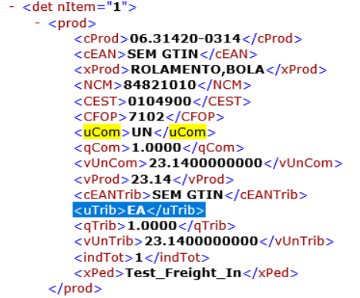

Measure "EA" in portuguese is "CX", and the government system doesn't approve NF-e that way.

To avoid that issue we change the below object:

Class ZTL_NFEE004P_ADJUST_XML

Method FILL_ITEM

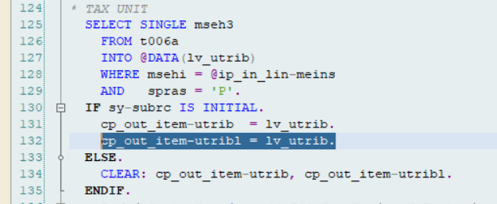

The field "UTRIBL" wasn't filled before this change, and that field is responsible to carry the modification to XML.

5 REQUEST LIST

GE1K905215 DISA.DEV EBS.IT - JC - Adjust XML translation of unit of measure